SMARTIO Quick Manual
Hold your SMARTIO facing the keypad with the speaker on the left and Mode button on the right of the device. Power button is on the bottom, and Volume buttons are on the top.
1.The Location of Function Keys
  - On the top: Volume Down (-) and Volume Up (+) buttons
  - On the front side: Speaker, keypad, Mode button, LED
  - On the right side: Mike, USB-C, Earphone jack
  - On the bottom: Power Button
  - Functions:
Power Button : Press and hold to turn the device on and off.
Volume Button : Raise or lower the volume.
Mode Button : Select Navigation Mode or Input Mode.
USB-C : charge battery or update firmware.

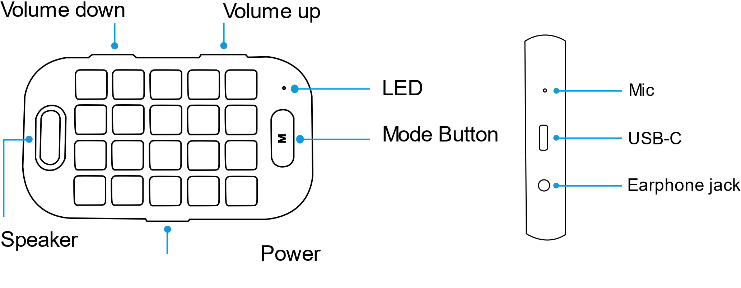

2. Power On/Off, Keypad Lock, Silent Mode
  - Power On : Press and hold Power button. You will hear “Power is on,” and the device will be turned on.
  - Power Off : Press and hold Power button. You will hear “Power is off,” and the device will be turned off.
  - Lock Your Keypad : Press N5 key for more than 5 seconds. You will hear, “The keypad is locked,” and the keypad will be locked.
  - Unlock Your Keypad : Press N5 key for more than 5 seconds. You will hear, “The keypad is unlocked,” and the keypad will be unlocked.
  - Silent Mode : If you press Volume Down (-) and Volume Up (+) buttons simultaneously, you will hear “The audio is muted,” and the device will be in silent mode.
  - Release Silent Mode : Press Volume Down (-) and Volume Up (+) buttons simultaneously to release your device from Silent Mode as you will hear “The audio is unmuted.”

Bluetooth Pairing
  - Initial Pairing: Turn on your SMARTIO. After activating Bluetooth on your smartphone, search and connect SMARTIO. When the pairing is completed, you will hear “Bluetooth is connected.”
  - Reconnecting: If you lost Bluetooth connection, try to reconnect by pressing Mode button.
- OS Settings
  - OS settings: Set up the OS of your SMARTIO.
    - IOS : Volume Down button + L1 key + Mode button. You will hear “IOS Mode.”
    - Android : Volume Up button + L1 key+ Mode button. You will hear “Android Mode.”
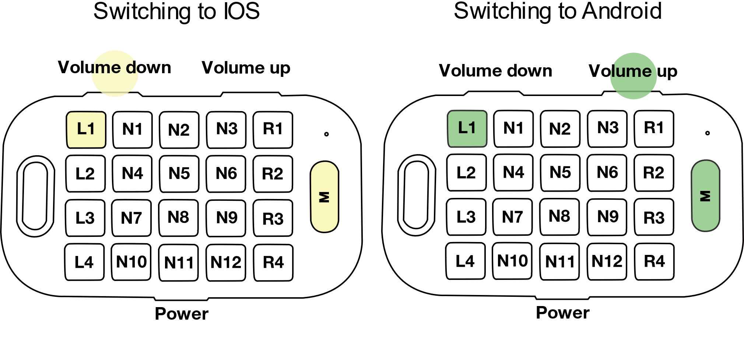

5. Battery
  - Checking the Charging Status: Mode button + Power button
    - You will hear “25% of the battery is left” when there is a 25% of battery left.
    - You will hear “50% of the battery is left” when there is a 50% of battery left.
    - You will hear “More than 75% of the battery is left” when there is a 75% of battery left.
  - How to Charge Your Battery: Use a USB-C type charging cable. When your battery is fully charged, you will hear “Charging has completed” with green light on.
  - Sleep Mode : If there is no activity on your SMARTIO for 5 minutes, it is automatically switched to Sleep Mode. Press any button to start using the device, then the device will try connecting Bluetooth.
*When not in use, please turn off your SMARTIO to prevent a dead battery.

6. Mode Settings
  - Mode Settings : Press Mode button to toggle between Navigation Mode and Input Mode.
  - Braille input Mode: If you press R4 key for more than 3 seconds in Navigation Mode, you will hear “braille mode” and move to Braille Mode. Hold your SMARTIO facing the back of your keypad.
  - Browser Mode : If you press N12 key for more than 3 seconds, you will hear “browser mode” and move to Browser Mode.
7. Changing input language
  - Changing Language: Switch languages in Input Mode. Press L2 key to toggle between Arabic and English.
  - Language Synchronization: If the letters you typed in SMARTIO are not inputted in your smartphone properly: Press L2 key+ Mode button for more than 3 seconds to synchronize the language.
8. Input printed text
8.1 Capital letter: Type in letters while pressing L4 key (Shift).
8.2 Number and Symbol: Press L3 key to input numbers, and press L3 key again for additional symbols. To go back to Text Input Mode, press L1 key.
8.2.1 Backspace key : R1
8.2.2 Space key : R2
8.2.3 Enter key : R3

9. Input Braille
9.1 Basic input : N3,6,9,1,4,7 are Dot 1,2,3,4,5,6.
9.2 symbol input : If you want to input symbol, Press L4 key and type the symbol. And than Press L4 key again, you will return to Braille input mode.
